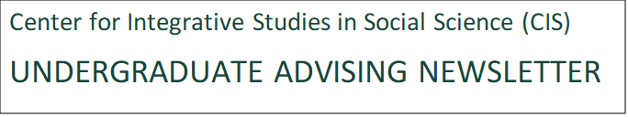

Get the latest campus updates from the MSU CIS (Center for Integrative Studies in Social Science), which includes majors in IDS (Interdisciplinary Studies) and GLIS (Global and International Studies).

February 15, 2024

March 4: Important Date from the Registrar’s Office: This is the middle of the spring semester and the last day to drop most regularly scheduled courses, with no grade recorded and no refund. You may read the specific dates and deadlines for any course on the Class Search web page for Spring Semester, 2024.

UURAF Late Registration Available

The 26th annual University Undergraduate Research and Arts Forum (UURAF) will take place on Friday, April 12, 2024, at the Breslin Center and online. Students can present research that is still in progress and also present research that is already completed. Visit our website for more information.

UURAF Registration Portal

The DSAC (Deans Student Advisory Committee in Social Science) awards—Humanitarian, Outstanding Leadership, and Undergraduate Research—are available for application. The deadline to apply is Monday, March 4, 2024. These awards are designed to honor students who would not otherwise be acknowledged for their contributions to the College of Social Science. Share this link with your students and encourage them to apply. The selection committee includes DSAC members, to ensure that our students are well represented.
https://socialscience.msu.edu/undergraduate/current-students/get-involved/Social%20Science%20Achievement%20Gala.html

Scholarships: International Studies and Programs would like to share four additional scholarships available for undergraduate and graduate students, all with an application deadline of March 1st, 2024. This includes the new S&S Foundation Scholarship which is available for the first time this year. Please consider sharing these resources with students you know who may be eligible for these funds. Email ISP.intladvancement@campusad.msu.edu for questions and application assistance on the following four scholarships:

- EMC Education Abroad Scholarship
  - Financial support for education abroad
  - $2,500 for undergraduate and graduate MSU students who are members of organizations belonging to the National Pan-Hellenic Council (NPHC).
- Thornton Opportunity Scholarship
  - Support for domestic and international undergraduate students who have experienced hardships due to war or conflict and have demonstrated financial need.
- ECLAT Foundation Graduate Scholarship
  - $5,000 toward tuition expenses for graduate students who are citizens or permanent residents of China or Taiwan. Preference will be given to students admitted to the Broad College MBA or College of Engineering.
- S&S Foundation Scholarship
  - At least $10,000 for students with financial need who are pursuing a degree in a STEM field and are citizens or permanent residents of any country within Latin America, the Caribbean, Asia or Africa.

As a reminder, the three scholarships below were previously shared and are also open until March 1st. Questions regarding these should be directed to ISP.Scholarship@msu.edu
- Walker Hill International Award
  - At least $1,000 for pre-dissertation visits to a doctoral research site in a country outside the United States.
- Gliozzo Dissertation Research Scholarship
  - At least $1,000 for MSU doctoral students to support field research abroad in support of the student’s dissertation.
- Claffey Meyer Travel Grant
  - At least $2,000 for domestic students who intend to travel to developing countries for the purpose of providing technical assistance, participating in research, or engaging in service.
Thank you,
Alexandra

Alexandra Jarvis
Program Administrator
Global Youth Advancement Network
Michigan State University

Student Leadership Awards Nominations Due soon
Greetings Spartans:
The Office of Spartan Experiences in the Division of Student Life and Engagement would like to invite you to nominate students, student leaders, advisors, organizations, events, and programs for 2024 Student Leadership Excellence Awards. The Student Leadership Excellence Awards are designed to recognize outstanding leadership excellence by students, student leaders, advisors, organizations, and programs that are creating change and positive impacts to MSU and associated communities. We are excited to celebrate the 23rd anniversary of the Student Leadership Excellence Awards program this year.
The theme for this year’s program is:
“Celebrating Relentless Leadership Excellence”
The nomination deadline for awards is Friday, March 8th, 2024. Please nominate through our online forms via our website:
https://studentlife.msu.edu/leadership/leadership-awards-reception.html.
Nominations will only be accepted through the on-line form. Nominees can only be nominated for one individual award category, no more than two organizational award categories and one program award category. Nominations submitted not adhering to this standard will not be accepted.

The Student Leadership Excellence Awards program will take place on Wednesday, April 3rd, 2024, at 7:00 pm in the MSU Kellogg Hotel and Conference Center, Ballrooms B and C.
Although it is a busy time of year, please take the time to recognize those that are deserving of recognition for their hard work in creating a better world for us all. Thank you in advance for making a nomination for the Student Leadership Excellence Awards. We look forward to receiving your nominations.
For more information on awards, please contact Jakaira Lynn via email: lynnjaka@msu.edu

Looking for a job making a difference? Visit the Student PIRGs- at the Environmental, Energy, Natural Resources, and Sustainability Career Fair Thursday 2/15/24 (see next page)

As an organizer you’ll train student activists to make a difference on key issues:
- Commit states to 100% clean energy to fight climate change
- Increase youth voter participation in elections
- Fight plastic pollution and protect our oceans
- Increase higher education affordability
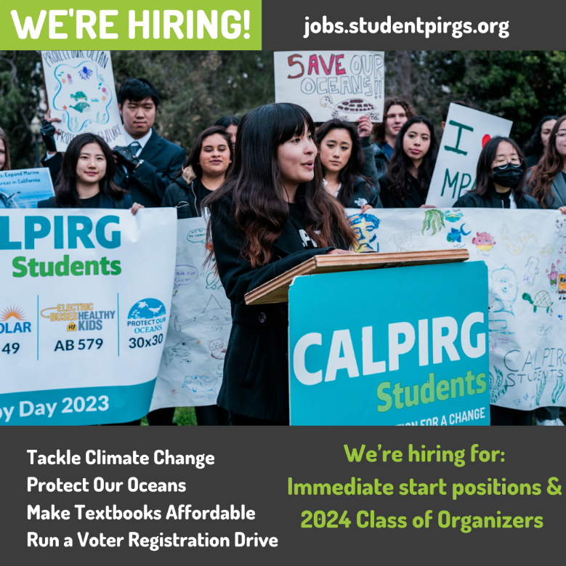

To hear more about the job, Fill out this form to learn more and visit us directly at our table at the MSU Environmental, Energy, Natural Resources, and Sustainability Career Fair Thursday 2/15/24 from 12-4pm.

Best,
Jeana Marquardt
Campus Organizer
Student PIRGs

VIPP Cultural Ambassador Opportunities - 2024
German Fulbright Summer Institute
Study of the U.S. Institute for Student Leaders on Civic Engagement (SUSI) VIPP Global Summer School

Program Descriptions

The Visiting International Professional Program (VIPP) at MSU is proud to host three exciting international programs on campus this summer. The three programs, with brief descriptions, being hosted are:

The German Fulbright Summer Institute:

In partnership with the German Fulbright Commission, MSU is offering an exciting project-based summer institute to a group of 30 German undergraduate students and other international students from around the world. The Summer Institute focuses on cross cultural communication, leadership, and business and social entrepreneurship. Check out last year’s program.

Study of the U.S. Institute on Civic Engagement (SUSI):

Sponsored by the U.S. Department of State Bureau of Educational and Cultural Affairs, and in partnership with Meridian International Center, MSU will host the 2024 SUSI program. During the five- week intensive program, student leaders from universities across Europe will examine how citizens have shaped U.S. history through community organizing and social movements. Students will explore topics such as citizenship, public culture, economic development, grassroots activism, political leadership, and volunteerism. Check out last year’s program.

VIPP Global Summer School:

Hosted at MSU, the Global Summer School Program offers an opportunity for international university students to experience American culture and campus life. Students will enjoy cross-cultural collaborative learning, work with classmates from around the world, and learn from the world-class faculty at MSU!
Programs feature hands-on experiential learning, teach real-world problem solving, and are led by expert instructors. Check out last year’s program.

Cultural Ambassador (Class Assistantship) Description

To enhance the learning experience and cultural exposure for the students, we are recruiting 10 - 12 MSU students to take part in the program as Cultural Ambassadors and Class Assistants. This will be a great opportunity to practice German and other languages, participate in collaborative learning, and engage with a meaningful international experience through academic and cultural exchange.

If selected, you will be required to participate in some class activities including group projects, field trips, and social events. You may be assigned specific tasks during the program such as leading discussions, helping with breakout sessions, organizing group project meetings, leading field trips, and writing short

news stories. Foreign language ability is preferred but not required for participation. You must have a
valid driver’s license.

Students must be available for the program they agreed to participate in. Such dates are listed below.

Summer Institute Dates and Schedule (subject to minor changes) SUSI 2024: June 20, 2024 – July 24, 2024

German Fulbright Summer Institute: July 13, 2024 - August 3, 2024

VIPP Global Summer School: July 21, 2024—August 3, 2024

Daily schedule will be finalized prior to the program's start date.

About 30 hours per week working hours including weekends and evenings.

Application
Apply here. Application will open on February 1, 2024, and close on March 1, 2024.

You will be notified with the selection decision before the end of March. Contact us at vipp@msu.edu for further information.

Handshake ID
#8629689

Payment
$20 per hour.

MSU Student Life & Engagement has more than 20 scholarships available for undergraduate students. The application deadline for most of these scholarships is March 4, 2024. For more information and to apply, visit the MSU Student Life & Engagement scholarship page: https://sle.msu.edu/scholarships
If you have any questions, please contact Lisa Vanwelsenaers at vanwelse@msu.edu

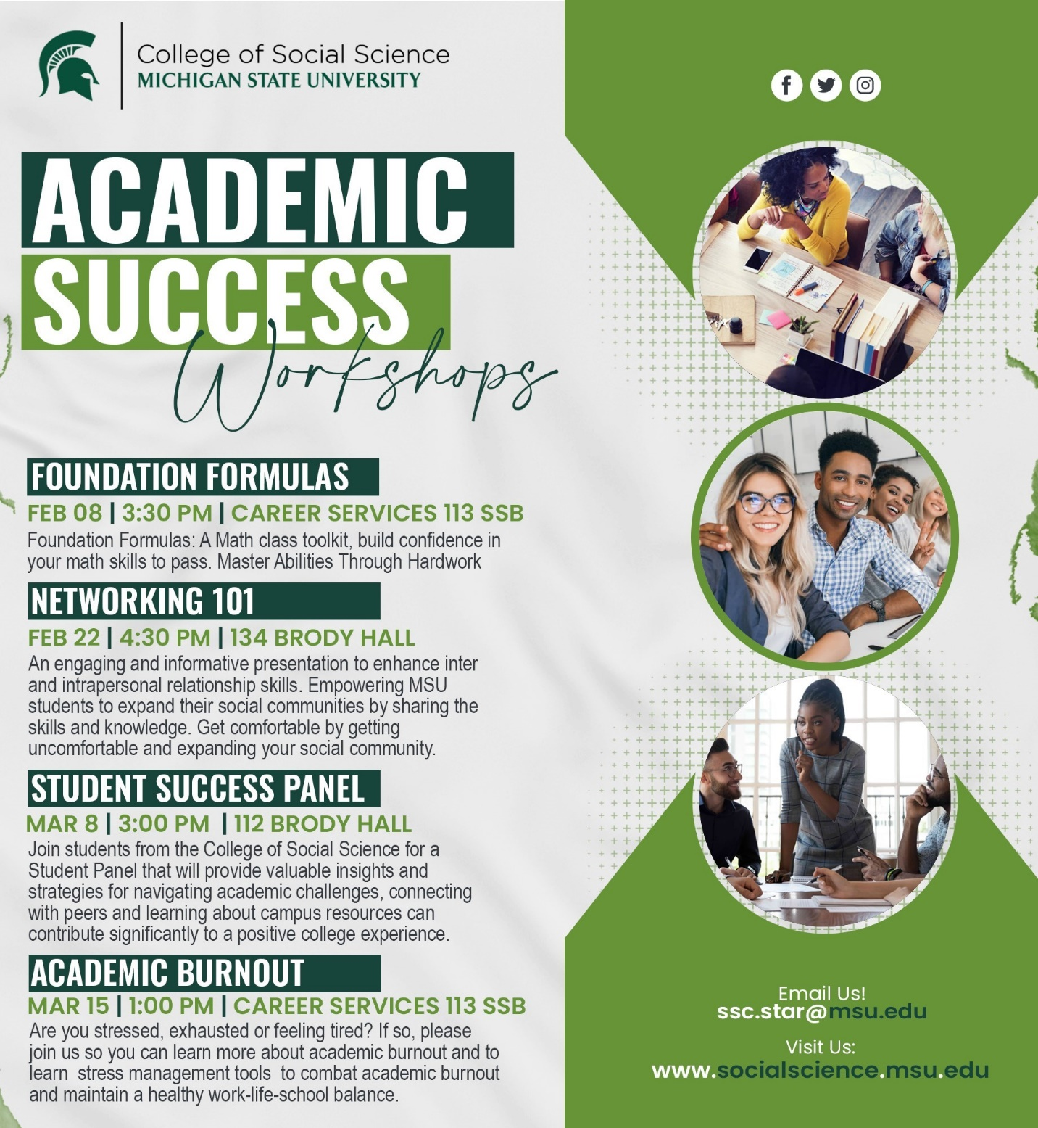

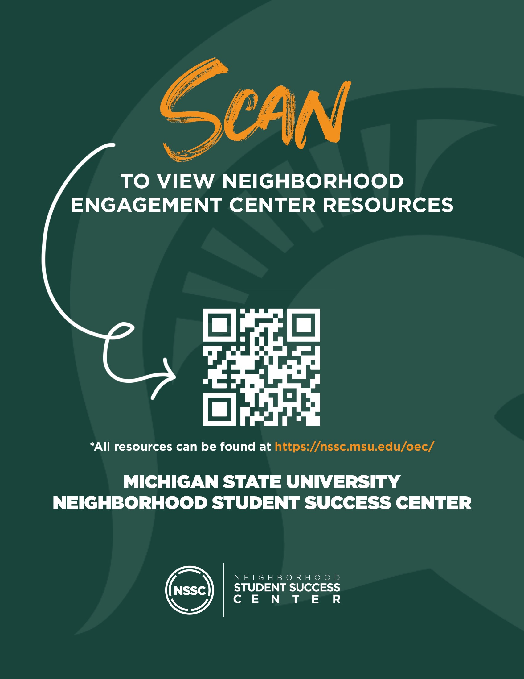
Drop-in Career Advising - MSU Career Services focuses on career related topics for freshmen and sophomores. Now is the time to get a head start on resumes, interviews, career resources, LinkedIn & Handshake, navigating career fairs, summer internships, and more!
Brody: Brody, outside room 160 Brody Hall, Thursdays 3:00-6:00pm
River Trail: outside River Trail Engagement Center, room C101 McDonel, Tuesdays 4:00-6:30pm
NSSC Peer Educators - Whether it's managing your time more efficiently, improving your study skills, or learning how to learn, the NSSC Peer Educators are here to help. For a list of days, times, locations, and services offered by each peer educator go to https://nssc.msu.edu/oec/ and click NSSC Peer Educators.
Recreation Sports and Fitness Services - Zumba. A fusion of Latin and international music-dance themes that create a dynamic and exciting class. Based on the principle that a workout should be "fun and easy to do." The routines feature aerobic-fitness interval training with a combination of fast and slow rhythms that tone and sculpt the body
MOSAIC's Multipurpose Room (2nd floor MSU Union), Mondays, 7p - 7:45p
For more information on each of the above resources, or for a list of all neighborhood resources, scan the QR code in the attached flyer or visit https://nssc.msu.edu/oec/

